

A Mini Project Report on
“Blood Bank Management System”

Submitted
In partial fulfilment of the requirement for the VI Semester of Bachelor of Technology in Computer Science and Engineering during the academic year 2019-20

Submitted By

SNEHASISH BANIK R17CS403
SRIYANSH GHOSH R17CS410
TV POONAM R17CS426

Under the Guidance of

Prof. Laxmi Jayannavar
Assistant Professor
School of C & IT

REVA UNIVERSITY
School of Computing and Information Technology
Bengaluru-560064
2019-20

2019-20
Research Paper Id: 620

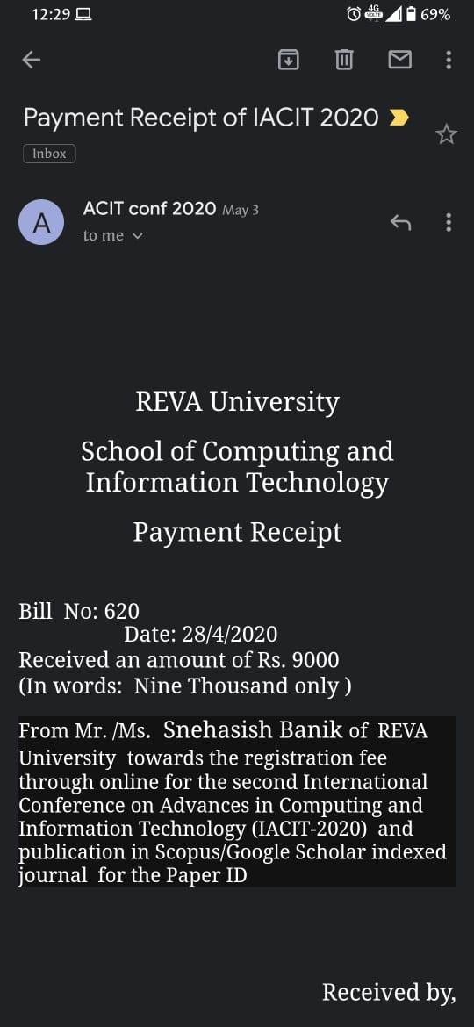

Payment receipt of ACIT conf 2020
Certificates

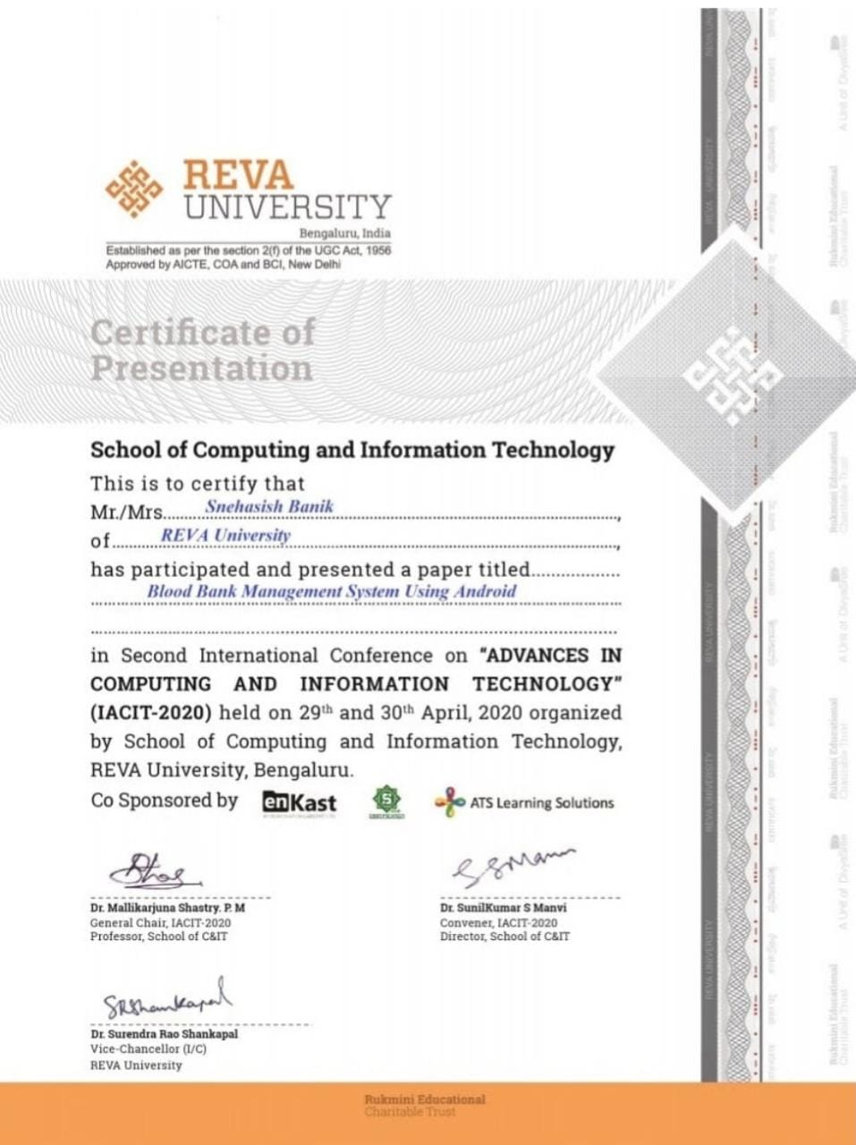
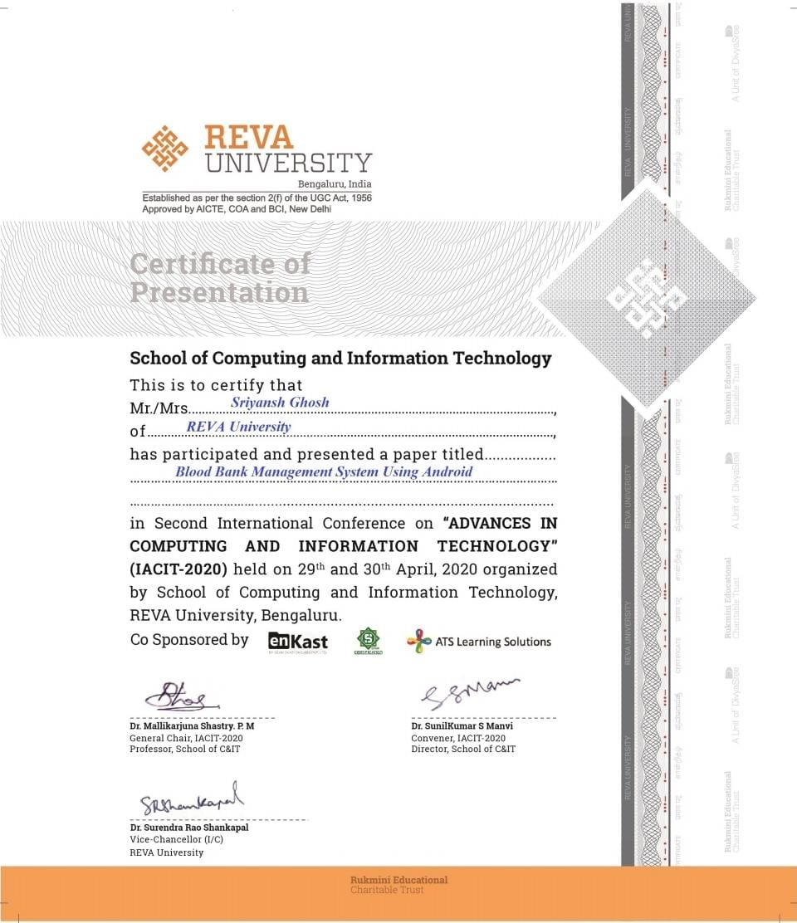
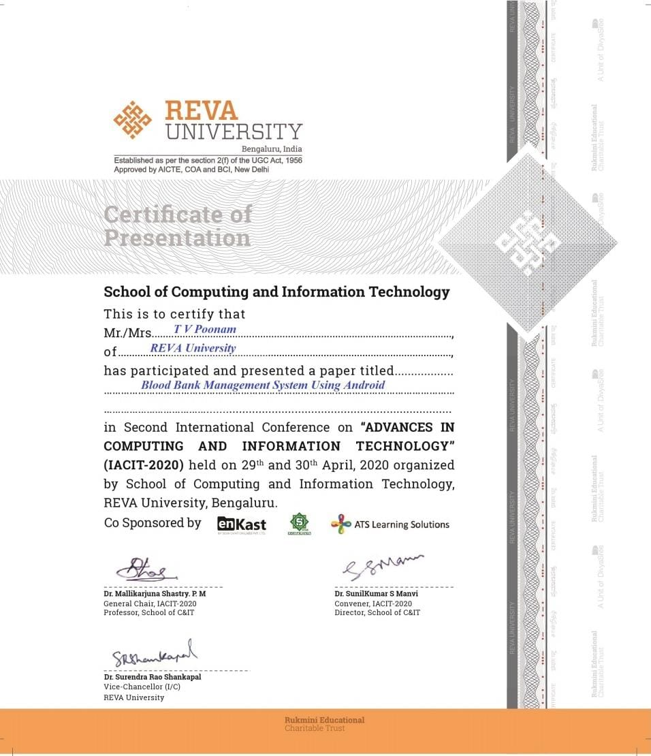

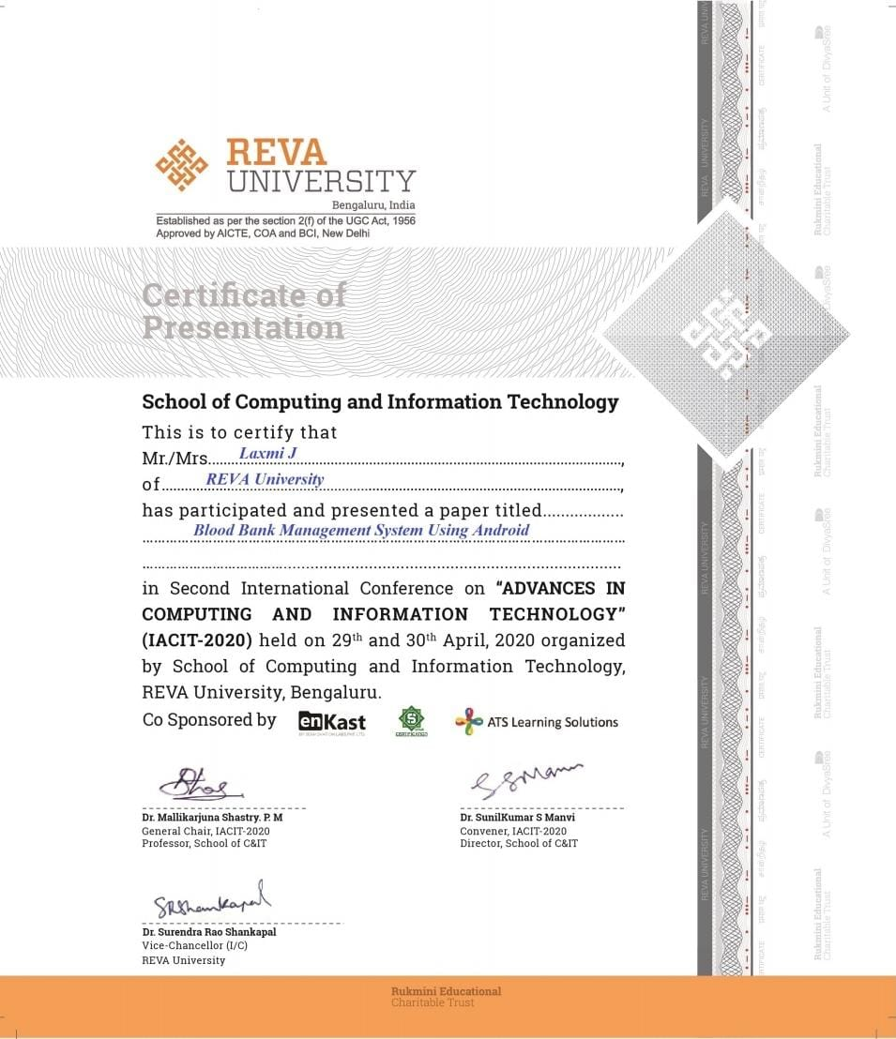

Scopus index journal publication link:
http://testmagzine.biz/index.php/testmagzine/article/view/8140
SCHOOL OF COMPUTING AND INFORMATION TECHNOLOGY

Certificate

This is to certify that the mini project entitled “Blood Bank Management System” is a bonafide work carried out by Snehasish Banik, Sriyansh Ghosh, TV Poonam bearing SRN: R17CS403, R17CS410, R17CS426 respectively in partial fulfilment of VI semester of Computer Science and Engineering program of Bachelor of Technology, REVA University during the academic year 2019-20. It is certified that all the corrections/suggestions indicated for internal assessment have been incorporated in the report deposited in the school library. The mini project report has been approved as it satisfies the academic requirements in respect of mini-project prescribed for the VI semester of B.Tech - CSE program.

Signature and Date Signature and Date
------------------------ --------------------------
(Prof. Laxmi Jayannavar) (Dr. Sunilkumar S. Manvi)

Guide Director

Sl. No. | Name of the Examiner and Affiliation | Signature and Date
1.
2.

ACKNOWLEDGEMENT

Any given task achieved is never the result of efforts of a single individual. There are always a bunch of people who play an instrumental role is leading a task to its completion. Our joy at having successfully finished our mini project work would be incomplete without thanking everyone who helped us out along the way. We would like to express our sense of gratitude to our REVA University for providing us the means of attaining our most cherished goal.

We would like to thank our Hon’ble Chancellor, Dr. P. Shyama Raju, Hon’ble Vice-Chancellor, Dr. S. Y. Kulkarni for their immense support towards students to showcase innovative ideas.

We cannot express enough thanks to our respected Director, Dr. Sunilkumar S. Manvi for providing us with a highly conducive environment and encouraging the growth and creativity of each and every student. We would also like to offer our sincere gratitude to our Mini Project Coordinators, Prof. Kiran M, Prof. Sailaja Thota, Prof. Surekha Thota and Prof. Ashok K. Patil for the numerous learning opportunities that have been provided.

We would like to take this opportunity to express our gratitude to our Mini Project Guide, Prof. Laxmi Jayannavar, Assistant Professor for continuously supporting and guiding us in our every endeavor as well for taking a keen and active interest in the progress of every phase of our Mini Project. Thank you for providing us with the necessary inputs and suggestions for advancing with our Mini Project work. We deeply appreciate the wise guidance that sir has provided.

Finally, we would like to extend our sincere thanks to all the faculty members, staff from School of Computing and Information Technology.

SNEHASISH BANIK
SRIYANSH GHOSH
TV POONAM

TABLE OF CONTENTS

Chapter Page No.

- Introduction vii

- Literature Survey ix

- System Design and Analysis x

- System Requirement xiii

- Methodology xiv

- Experimental Result xvi

- Application xvii

- Conclusion xviii

- Future Enhancement xix

- References xx

LIST OF FIGURES

Figure No. Figure Caption Page No.

- System Design x

- Methodology xiv

- Flow Chart xv

- Snapshot of Receiver Form xvi

- Snapshot of Donor Form xvi

ABSTRACT

Availability of blood throughout emergencies is extremely vital for each single object. There area unit variety of electronic blood donation centers for effective communication between them and medical facilities. None of the net blood donation center offers the immediate contact amongst beneficiary and them. this can be the important draw back of the present framework. the present frameworks area unit tedious; need additional labor and big-ticket. This paper presents a correlation between existing bank framework and increased framework to enhance the effectiveness. The new concerns might increase the effectualness of current blood banks and facilitate to upgrade from standard desktop framework to moveable framework. The planned work any discusses the elements of increased framework in various views like the info being keep, information for future applications like reasonably blood teams being given and received by the people.
LBBRF is a private organization that functions as a place to donate blood. They give a charge to the person or
patient that is in needs of blood. However, the money that they collected is not for the profit for them but for recover
the expenses incurred in recruiting and educating donors. This is also to ensure that the blood transfusion is as safe
as possible. In Lions Bank & Research Foundation, They will make sure the availability of blood stock in their
blood bank. They also published the current status of blood stock in their website homepage. This is for them to
keep the website visitor especially donor informed about the needs of blood. They also inform the donor and the
public where and when is their next event. However, this blood bank does not provide any facility for the donor and
the patient. Therefore, they cannot know how many times that they have donated their blood. As for the donor, they
cannot know their blood screening result for each time they donate their blood. Without having this function in the
system, the donor cannot monitor his or her health condition. This will make the donor become unaware of their
health condition.
LBBRF is a private organization that functions as a place to donate blood. They give a charge to the person or
patient that is in needs of blood. However, the money that they collected is not for the profit for them but for recover
the expenses incurred in recruiting and educating donors. This is also to ensure that the blood transfusion is as safe
as possible. In Lions Bank & Research Foundation, They will make sure the availability of blood stock in their
blood bank. They also published the current status of blood stock in their website homepage. This is for them to
keep the website visitor especially donor informed about the needs of blood. They also inform the donor and the
public where and when is their next event. However, this blood bank does not provide any facility for the donor and
the patient. Therefore, they cannot know how many times that they have donated their blood. As for the donor, they
cannot know their blood screening result for each time they donate their blood. Without having this function in the
system, the donor cannot monitor his or her health condition. This will make the donor become unaware of their
health condition.
LBBRF is a private organization that functions as a place to donate blood. They give a charge to the person or
patient that is in needs of blood. However, the money that they collected is not for the profit for them but for recover
the expenses incurred in recruiting and educating donors. This is also to ensure that the blood transfusion is as safe
as possible. In Lions Bank & Research Foundation, They will make sure the availability of blood stock in their
blood bank. They also published the current status of blood stock in their website homepage. This is for them to
keep the website visitor especially donor informed about the needs of blood. They also inform the donor and the
public where and when is their next event. However, this blood bank does not provide any facility for the donor and
the patient. Therefore, they cannot know how many times that they have donated their blood. As for the donor, they
cannot know their blood screening result for each time they donate their blood. Without having this function in the
system, the donor cannot monitor his or her health condition. This will make the donor become unaware of their
health condition.
LBBRF is a private organization that functions as a place to donate blood. They give a charge to the person or
patient that is in needs of blood. However, the money that they collected is not for the profit for them but for recover
the expenses incurred in recruiting and educating donors. This is also to ensure that the blood transfusion is as safe
as possible. In Lions Bank & Research Foundation, They will make sure the availability of blood stock in their
blood bank. They also published the current status of blood stock in their website homepage. This is for them to
keep the website visitor especially donor informed about the needs of blood. They also inform the donor and the
public where and when is their next event. However, this blood bank does not provide any facility for the donor and
the patient. Therefore, they cannot know how many times that they have donated their blood. As for the donor, they
cannot know their blood screening result for each time they donate their blood. Without having this function in the
system, the donor cannot monitor his or her health condition. This will make the donor become unaware of their
health condition.
LBBRF is a private organization that functions as a place to donate blood. They give a charge to the person or
patient that is in needs of blood. However, the money that they collected is not for the profit for them but for recover
the expenses incurred in recruiting and educating donors. This is also to ensure that the blood transfusion is as safe
as possible. In Lions Bank & Research Foundation, They will make sure the availability of blood stock in their
blood bank. They also published the current status of blood stock in their website homepage. This is for them to
keep the website visitor especially donor informed about the needs of blood. They also inform the donor and the
public where and when is their next event. However, this blood bank does not provide any facility for the donor and
the patient. Therefore, they cannot know how many times that they have donated their blood. As for the donor, they
cannot know their blood screening result for each time they donate their blood. Without having this function in the
system, the donor cannot monitor his or her health condition. This will make the donor become unaware of their
health condition.
LBBRF is a private organization that functions as a place to donate blood. They give a charge to the person or
patient that is in needs of blood. However, the money that they collected is not for the profit for them but for recover
the expenses incurred in recruiting and educating donors. This is also to ensure that the blood transfusion is as safe
as possible. In Lions Bank & Research Foundation, They will make sure the availability of blood stock in their
blood bank. They also published the current status of blood stock in their website homepage. This is for them to
keep the website visitor especially donor informed about the needs of blood. They also inform the donor and the
public where and when is their next event. However, this blood bank does not provide any facility for the donor and
the patient. Therefore, they cannot know how many times that they have donated their blood. As for the donor, they
cannot know their blood screening result for each time they donate their blood. Without having this function in the
system, the donor cannot monitor his or her health condition. This will make the donor become unaware of their
health condition.
LBBRF is a private organization that functions as a place to donate blood. They give a charge to the person or
patient that is in needs of blood. However, the money that they collected is not for the profit for them but for recover
the expenses incurred in recruiting and educating donors. This is also to ensure that the blood transfusion is as safe
as possible. In Lions Bank & Research Foundation, They will make sure the availability of blood stock in their
blood bank. They also published the current status of blood stock in their website homepage. This is for them to
keep the website visitor especially donor informed about the needs of blood. They also inform the donor and the
public where and when is their next event. However, this blood bank does not provide any facility for the donor and
the patient. Therefore, they cannot know how many times that they have donated their blood. As for the donor, they
cannot know their blood screening result for each time they donate their blood. Without having this function in the
system, the donor cannot monitor his or her health condition. This will make the donor become unaware of their
health condition.
LBBRF is a private organization that functions as a place to donate blood. They give a charge to the person or
patient that is in needs of blood. However, the money that they collected is not for the profit for them but for recover
the expenses incurred in recruiting and educating donors. This is also to ensure that the blood transfusion is as safe
as possible. In Lions Bank & Research Foundation, They will make sure the availability of blood stock in their
blood bank. They also published the current status of blood stock in their website homepage. This is for them to
keep the website visitor especially donor informed about the needs of blood. They also inform the donor and the
public where and when is their next event. However, this blood bank does not provide any facility for the donor and
the patient. Therefore, they cannot know how many times that they have donated their blood. As for the donor, they
cannot know their blood screening result for each time they donate their blood. Without having this function in the
system, the donor cannot monitor his or her health condition. This will make the donor become unaware of their
health condition.
LBBRF is a private organization that functions as a place to donate blood. They give a charge to the person or
patient that is in needs of blood. However, the money that they collected is not for the profit for them but for recover
the expenses incurred in recruiting and educating donors. This is also to ensure that the blood transfusion is as safe
as possible. In Lions Bank & Research Foundation, They will make sure the availability of blood stock in their
blood bank. They also published the current status of blood stock in their website homepage. This is for them to
keep the website visitor especially donor informed about the needs of blood. They also inform the donor and the
public where and when is their next event. However, this blood bank does not provide any facility for the donor and
the patient. Therefore, they cannot know how many times that they have donated their blood. As for the donor, they
cannot know their blood screening result for each time they donate their blood. Without having this function in the
system, the donor cannot monitor his or her health condition. This will make the donor become unaware of their
health condition.

- INTRODUCTION

This project acts as an important role in saving life of human beings and which is also its main aim. The project Android Blood Bank system is developed so that users can view the information about registered blood donors such as name, address, and other such personal information along with their details of blood group and other medical information of donor. The project also has a login page where in the user is required to register and only then can view the availability of blood and may also register to donate blood if he/she wishes to. This project requires internet access and thus there is a disadvantage of internet failure. Thus this application helps to select the right donor online instantly using medical details along with the blood group. The main aim of developing this application is to reduce the time to a great extent that is spent in searching for the right donor and the availability of blood required. Thus this application provides the required information in no time and also helps in quicker decision making.

The "Blood donation center Management System" has been created to supersede the issues winning in the rehearsing manual framework. This product is bolstered to take out and now and again lessen the hardships looked by this current framework. In addition this framework is intended for the specific need of the organization to do activities in a smooth and viable way. The application is decreased however much as could be expected to keep away from mistakes while entering the information[1]. It additionally gives mistake message while entering invalid information. No conventional information is required for the client to utilize this framework. Along these lines by this all it demonstrates it is easy to understand. Blood donation center Management System as portrayed above, can prompt mistake free, secure, dependable and quick administration framework [2-4]. It can help the client to focus on their different exercises rather to focus on the record keeping. Subsequently it will help association in better use of resources.Every association, regardless of whether huge or little, has difficulties to survive and dealing with the data of Blood Group, Blood Bank, Blood Stock, Record, Blood Cell [5-6]. Each Blood Bank Management System has distinctive Blood Bank needs, in this way we structure restrictive representative administration frameworks that are adjusted to your administrative prerequisites [7]. This is intended to aid key arranging, and will assist you with guaranteeing that your association is furnished with the correct degree of data and subtleties for your future objectives [8-10]. Likewise, for those bustling official who are consistently in a hurry, our frameworks accompany remote access highlights, which will permit you to deal with your workforce whenever, consistently [11-13]. These frameworks will at last permit you to all the more likely oversee assets.

  - Motivation

The Blood Bank Android Project is one of the great technical life saver application. The main aim of this application is to reduce the time spent in searching of blood donors in case of emergency. This motivates us to design a system which will keep track of all the latest updates relevant to the people who donate blood and who had donated blood in case of emergency.
This Blood Bank Android Project system will specify all the details related to the donor such as their name, their address, their mobile number, their blood group and so on. The one who need blood, just have to login into the system which will hardly take few seconds and then the one who needs the blood get access to all the available group of bloods in nearby blood banks as well as details of those who can donate blood in urgent.
  - Objective of the project
- The goals and objectives of the Blood Bank Management System are as follows:
- To provide a means for the blood bank to publicize and advertise blood donation programs.
- To allow the probable recipients to make search and match the volunteer donors, and make request for the blood.
- To provide an efficient donor and blood stock management functions to the blood bank by recording the donor and blood details.
- To improve the efficiency of blood stock management by alerting the blood bank staffs when the blood quantity is below it par level or when the blood stock has expired.

- LITERATURE SURVEY

Within this section we addressed numerous methodologies that researches have proposed within recent years for the development of blood bank application.

In 2015, Sayali Dhond, Pradnya Randhavan, Bhagyashali Munde, Rajnandini Patil, and Vikas Patil, proposed an android based cloud computing application for blood bank. This system propose that In many emergency situations, such as accidents, there is an immediate need for specific blood type. Despite increasing requirements for blood, only about 5% of the Indian population donates blood. User will just touch the button on mobile phone. Then he will automatically connect to the cloud and his location will be tracked by GPS. All information about the donors and blood bank is stored on the cloud. As per blood requirement, user can quickly get notification from blood bank within the radius of 5-10 km. If requested blood group is available in the blood bank then it will send positive reply message to the users. If requested stock is not available in the blood bank then blood bank send notification to all donors. If anyone is able to donate then he will reply to blood bank. Only a registered person, with willingness to donate blood, will be able to access the service. Cloud- based services can prove important in emergency blood delivery since they can enable central and immediate access to donors data and location from anywhere.

In 2015, Sultan Turhan, proposed a real time android application that Blood donor volunteers constitute the main supply source in an effective blood supply chain management. They feed blood stocks through their donation. In an emergency situation, if the stocks are insufficient, the only source of blood supply will be the people who come to the health center and donate the blood on a voluntary basis. It is certain that time is a very important component in such situation.

In 2014, T.Hilda Jenipha and R.Backiyalakshmi, they proposed a system which introduce connection of blood bank application with nearest hospitals. In this paper they introduced one of the most effective android application. In this application they have used GPS technology to track the information of the donor. The GPS can track the donor information about the range of 5km in circumfurance. This android application algorithm passed the most complex test case.

In 2012, Vikas Kulshreshtha and Sharad Maheshwari, proposed a real time blood bank application that discuss about the benefits of management information system in blood bank. In this context system it consists of input, output, processing of data into information and feedback or control. It justifies the need of management information system viz. Management information system assist managers as computer understands the problem of the managers and they are capable of solving the problem of the managers. This results the breakthrough in the management information system.

In 2012, Arvind Sharma and P.C. Gupta, They have focused to compare a variety of techniques, approaches and different tools and its impact on the healthcare sector. The goal of data mining application is to turn that data are facts, numbers, or text which can be processed by a computer into knowledge or information. The main purpose of data mining application in healthcare systems is to develop an automated tool for identifying and disseminating relevant healthcare information. The comparative study of different data mining applications, techniques and different methodologies applied for extracting knowledge from database generated in the healthcare industry.
- SYSTEM DESIGN AND ANALYSIS

The system is designed and developed keeping in view that it should be user-friendly, Searching should be easy, and it should have the good and easy display and user ease is given to the user.

The Interface of the system is developed keeping in mind that it should be good looking, attract, at first sight, easy to understand and self-explanatory.
The system is web-based and the user can have access to the system with or without the internet. The interface of the system is so flexible that it can arrange itself according to the size of the device in which the site is being used.

The efficiency of any system is concerned with the minimum processing time as well as the optimal use of system resources in designing the proposed system; the efficiency factor has been taken well into consideration.

The interface will be user-friendly so that a common user can use it easily. In our, we make it very easy for the user to jump from one section to another. Another uniqueness of the design id that it is based on the fluid interface, it can adjust itself according to the device in which the system is being used.

Data security and integrity is our topmost priority. We will make sure that private data of every single user must remain confidential and never be compromised. For this purpose, we will use effective security mechanisms.

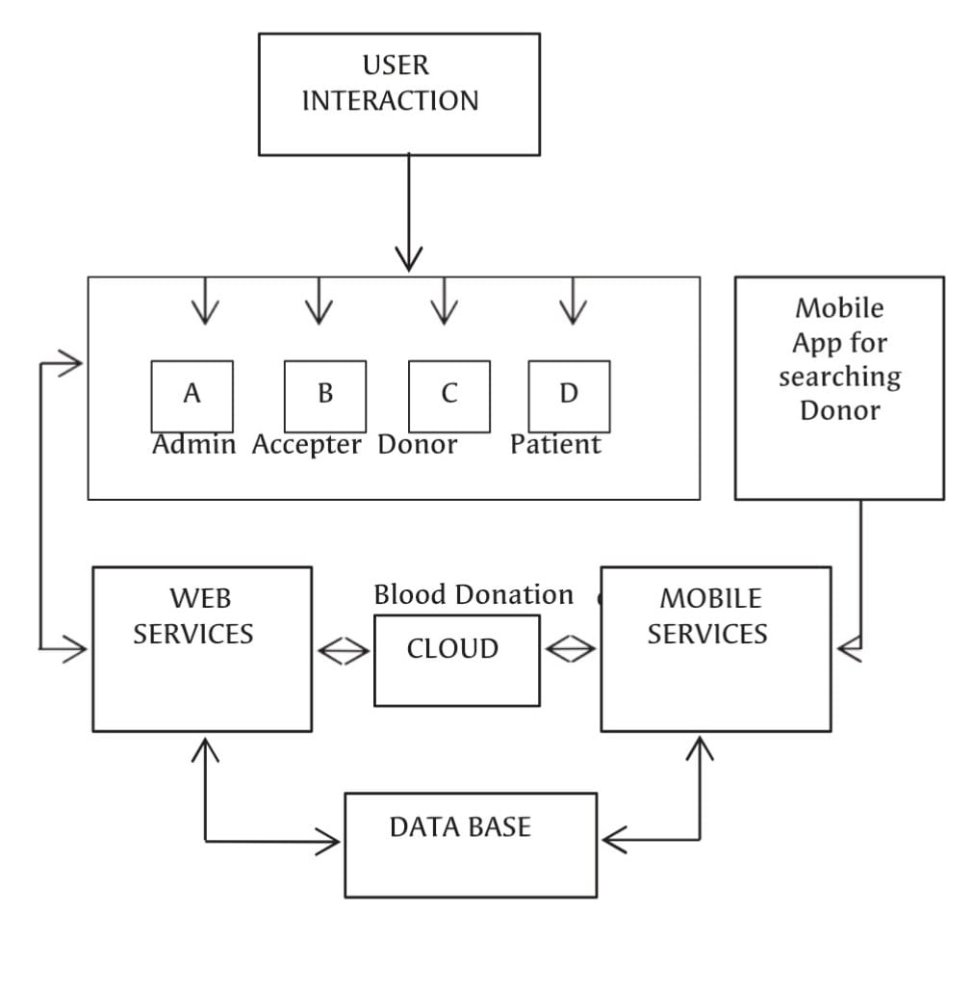

Fig 1. System Design

  - PROBLEM STATEMENT

The following problems occur in a typical blood donation management system:

• Personal profile accessibility ( P1 ) The donor’s information can only be updated by the administrators of the blood bank. A donor can update their information by calling, faxing, e-mailing, but not by themselves. This is a waste of time just for updating a piece of information and it may be troublesome for some donors.

• Lost or damaged card ( P2 ) A typical membership card can easily get damaged if it is exposed to the sunlight or weather and this causes to ruin the card’s barcode which is significantly important for retrieving records. If the card gets lost or stolen, the donor has to make a replacement card to keep their membership at the blood bank.

• Donation record accessibility ( P3 ) The donor ID card is the only tangible evidence that contains the donor’s recent donation records, if the card gets lost, donors may find it difficult to schedule their next appointment since they are not able to see the last time they had donated blood.

• Blood result notifications ( P4 ) After the process of blood donation, the donor will receive a card that only contains their name and blood type. They will not be notified of their blood result unless they request that information from the blood bank.

• Blood stock management ( P5 ) Blood banks are required to maintain account of blood bags in the inventory. This increases with each blood donation recorded in our system, and decreases as they are checked out upon hospital requests. Our system will need to keep the information up-to-date to ensure correctness of the inventory.

• Mailing by postal system ( P6 ) Blood banks will only mail donors when the donated blood is disqualified, however, this mail is sent through the postal system to the donor’s given address. If the donor’s address is recorded incorrectly, the mail will be sent to the wrong address and the donor will never be notified that their blood is rejected and given the reason for that.

  - FEASIBILITY STUDY
Whatever we think need not be feasible. It is wise to think about the feasibility of any problem we undertake. Feasibility is the study of impact, which happens in the organization by the development of a system. The impact can be either positive or negative. When the positives nominate the negatives, then the system is considered feasible. Here the feasibility study can be performed in two ways such as technical feasibility and Economical Feasibility.

    - Technical Feasibility
We can strongly say that it is technically feasible, since there will not be much difficulty in getting required resources for the development and maintaining the system as well. All the resources needed for the development of the website as well as the maintenance of the same is available in the organization here we are utilizing the resources which are available already.

    - Economical Feasibility
Development of this application is highly economically feasible .The organization needed not spend much money for the development of the system already available. The only thing is to be done is making an environment for the development with an effective supervision. If we are doing so, we can attain the maximum usability of the corresponding resources. Even after the development, the organization will not be in condition to invest more in the organization. Therefore, the system is economically feasible.

- SYSTEM REQUIREMENTS

  - Software Requirements:

- Windows XP/Windows 7/Windows 8/Windows 10
- Android Development Toolkit(ADT)
- Android Studio
- Text Editor : Sublime / Brackets
- Local Server XAMPP

  - Hardware Components:
- Processor – i3 and above
- Hard Disc – 4GB
- Memory – 4GB RAM
- Android Device

- METHODOLOGY

Given are the modules for the Android Blood Bank.
Admin Module: In this module, the administration work is done such as insertion and updation of new details, deletion of old details and so on.
User Module: In this module, users use to do their task such as registering themselves as an account member, getting details by filtering of their own choices,
Database Module: Here, in this module, all the database is maintained and queries are being executed. Every database has its own table which contains rows and tuple and every relation is being handles using SQL queries, given either by user in the form of statement or else by admin.
Content Module: In this module, some basic content will be share after each time limit, for regular updation regarding blood disease and its curing periods.
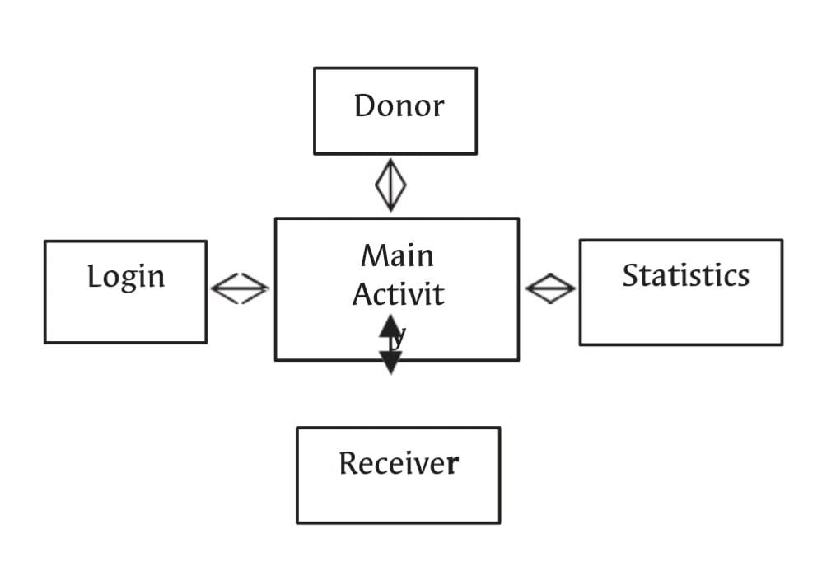
Fig 2. Methodology

The result of this application is notice and reaction from blood donation center for blood. The focal blood donation center will have a database of the check of blood packs for the separate blood gatherings. In the event that any of the tally goes low, the framework will inform the specialists and a blood camp might be sorted out for the filling of the blood lack. The littler blood donation center may likewise work in the comparable design, exactly when there will be any deficiency the national bank will be educated and the blood will be made accessible. The calculation of the proposed work is referenced beneath. The sources of info I and P are of character type.
The significant advances are-
Stage 1: If User is enrolled then give User Id (I) and secret key (P) else Create new record;
Stage 2: While blood stock gets low Send notice to contributors for blood gift camp;
Stage 3: If there is demand from client for blood, this will show in the database.
Stage 4: Check for blood accessibility at blood donation center;
Stage 5: If blood isn't accessible send notice from blood donation center to the enrolled Donors;
Stage 6: Check conditions for blood gift and different variables and past history;
Stage 7: If conditions are fulfilled acknowledge it;
Stage 8: If Conditions are not fulfilled at that point send warning to different contributors who are qualified;

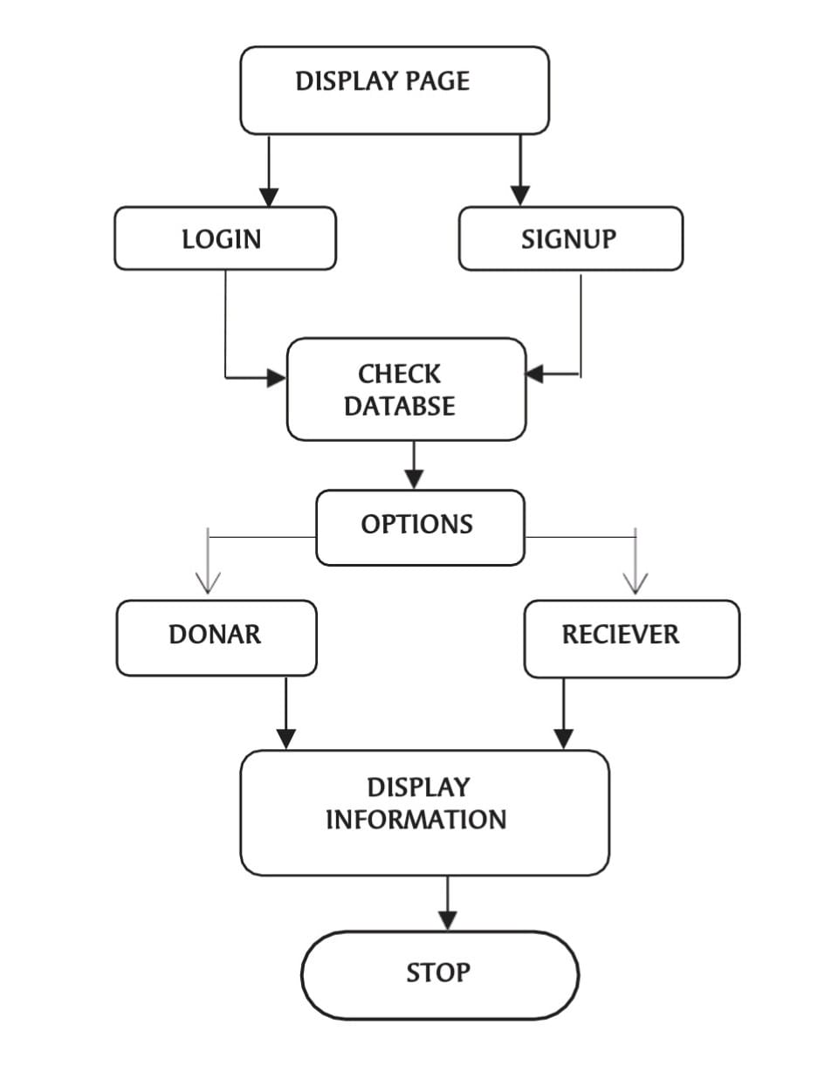

Fig 3. Flow chart

- EXPERIMENTAL RESULTS

Right now it has been put on application improvement for versatile gadgets like cell phones utilizing accessible programming. The application created is an alluring application helpful for clients having low gadget memory in applications. This application can be downloaded in any android forms above than 4.1 (Jellybean). The primary favorable circumstances of the proposed application are-
Expanded commitment and communications: This ready to assist the client with accessing the application so effectively which does excludes any pop-ups, standards and so forth. Client may draw in with their own errand and at the same time can see the entire year exchange reports.
Moment Access: App doesn't require a lot of time to open and play out its undertaking. This can be gotten to in a split second.
Expanded security with existing frameworks: It stores all the information in a database which is verify information and can be seen through hard and fast the months with no issue.
Progressively effective business process: Mobile applications offer speedy data and moment backing to clients constantly and wherever they required. All the key data are accessible on their cell phone only a tick away. Numerous new advancements, for example, push cautions may likewise be sent to their cell phones when new information or updates are accessible

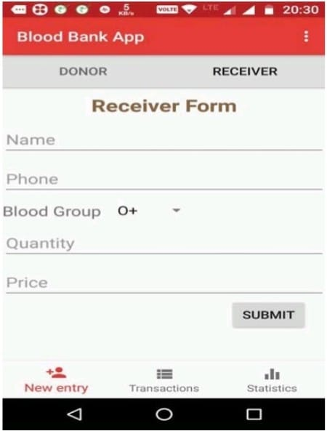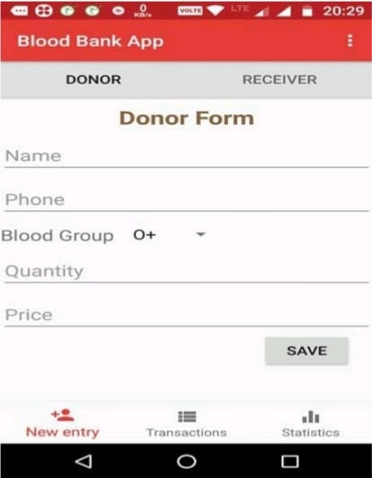

Fig 4. Snapshot of Receiver Form Fig 5. Snapshot of Donor Form

- APPLICATIONS

- This application can be used by any common people.
- The application can prove very beneficial in to the clinics, hospitals as the requirement is very high in such places.
- This application will use Firebase Realtime Database to collect and organize information of blood donors with fast and efficent search.
- This application will be very useful for finding blood donors in emergencies.
- Rare blood groups could be easily found.
- This application will provide all information of the donor including all past health related issues
- This automated Blood Bank Android Project will reduce the time and efforts for finding the right choice of donor for the needy receiver and thus most of the times helps the person to save his/her life also.
- The proposed Blood Bank Android Project system will help the needy person, access to all the donors of the blood of the particular group, nearby to their place, in a minutes of time. The details will include the name of the donor, his/her blood group, contact number and address
- This Blood Bank Android Project system will specify all the details related to the donor such as their name, their address, their mobile number, their blood group and so on. The one who need blood, just have to login into the system which will hardly take few seconds and then the one who needs the blood get access to all the available group of bloods in nearby blood banks as well as details of those who can donate blood in urgent.

- CONCLUSION

The proposed Android Application is easy to understand and simple to use when contrasted with existing blood donation center applications. In existing interfaces their insights shows what number of units of required blood bunch are accessible. The reports area shows the month wherein blood bunch are being appropriated and gotten. Right now name enrollment, telephone no and blood bunches should be given are incorporated. It likewise incorporates the blood amount to be put away in the application database. This can be called as new section as a client may enter his/her subtleties in the database. While in the recipient's structure this has person's name, telephone no (which a client can contact), their blood bunches should be gotten and the aggregate sum of amount. In the wake of presenting these information in the database, these fields are noticeable during exchange process. This shows how much

- FUTURE ENHANCEMENT

The current web based system’s in India for Blood Bank are not available according to the user’s requirement as they are deployed on web which are handy to use as they can be accessed in the case of emergency or an trauma Situation. The Mobility provided By Android based system which is accessible on mobile through Application are available on the go.
Location Accuracy Web based system provides the list of Blood banks with unique Identifier in nearest city, which is not that feasible as compared to direct access of mobile application as that of surfing the internet on personal system. Using GPS location identification of the applicant towards the blood bank application will provide location and path for nearest blood bank system.
Highly Trained Dataset Dataset Training i.e., data storage, manipulation, service etc., provides a great supporting model for the Application. The filtered dataset in which is uniformly structured helps end user to access this information and make fruit from it.The key features and information are date of birth of the donor as well as patient, blood group of the patient/ donor, date of last blood donated, mobile number, address with city and state, email id. It provides the criteria according hospital, blood bank wise advance search for the list and retrieval of data.
Inventory Management There are many Web Based Application which stores and provides information of both user’s like donor of blood and blood bag applicant. The blood bank Organization are relatively very large in the context of their physical and geographical aspects. So the inventory management of the Blood bank Systems is very necessary the information to be handled is very vast.Generation of report for the inventories used in the application should be properly done. Inventory includes the patient, donor, hospitals, blood banks, stock and the seeker inventory. Secondly the blood bags inventory should be discarded automatically once it has expired and the expiry policy is 21 days from the day of inventoryincluded, so proper record should be kept for the expired blood as it will save manual work of the manager who is inserting the record into database. 4.4 System Security The Blood Bank management systems facilitate the application with advanced security feature like validation and verification for web base application. This security service is provided by the android application were the user is Already registered to the system and its profile related information is stored And maintained for the further validation and verification of the user.
Alert System In case of emergency were the availability of blood is not known and the time is the major concern for user as they cannot manually search for required blood from each hospital and blood banks. So the Application provides an alert button which as soon as is clicked the information according to the best search attribute id displayed to the user profile with the nearest hospital and blood bank with its route to the destination.

10. REFERENCES

[1] Vikas Kulshreshtha and Sharad Maheshwari, “Benefits of Management Information System in Blood Bank”, International Journal of Engineering and Science, Vol. 1, Issue 12, PP 05-07, 2012.
[2] Hayes, Helen and Onkar Sharma, "A decade of experience with a common first year program for computer science, information systems and information technology majors". Journal of Computing Sciences in Colleges, Vol. 18, No. 3 pp. 217–227, 2003.
[3] Polack, Jennifer, "Planning a CIS Education Within a CS Framework". Journal of Computing Sciences in Colleges, Vol. 25, No. 2, pp. 100–106, 2009.
[4] J. Scott Armstrong, "The Value of Formal Planning for Strategic Decisions: A Reply". Strategic Management Journal, Vol. 7, pp. 183–185, 1986.
[5] Sayali Dhond, Pradnya Randhavan, Bhagyashali Munde, Rajnandini Patil, and Vikas Patil, “Android Based Health Application in Cloud Computing For Blood Bank”, International Engineering Research Journal (IERJ) Volume 1 Issue,2015.
[6] T.Hilda Jenipha and R.Backiyalakshmi, “Android Blood Donor Life Saving Application in Cloud Computing”, American Journal of Engineering Research (AJER), Volume 03, Issue 02, pp. 105-108, 2014.
[7] P. Priya, V. Saranya, S. Shabana and Kavitha Subramani, “The optimization of Blood Donor Information and Management System by Technopedia,” International Journal of Innovative Research in Science, Engineering and Technology, Volume 3, Special Issue 1, 2014.
[8] Sultan Turhan, “An Android Application for Volunteer Blood Donors”, Computer Science & Information Technology- CSCP, pp. 23–30, 2015.
[9] Catassi, C. A., Petersen, E. L. “The Blood Inventory Control SystemHelping Blood Bank Management Through Computerized Inventory Control”, Transfusion, Vol. 7, No. 60, 1967.
[10] Arvind Sharma and P.C. Gupta, “Predicting the Number of Blood Donors through their Age and Blood Group by using Data Mining Tool”, International Journal of Communication and Computer Technologies, Volume 01, No.6, Issue 02, 2012.
[11] PJ Saberton, Antonio Paez, K Bruce Newbold and Nancy M Heddle, “Geographical variations in the correlates of blood donor turnout rates: An investigation of Canadian metropolitan areas”, International Journal of Health Geographics, Vol. 8, No.56,2009.

[12] T. Santhanm and Shyam Sunderam, “Application of Cart Algorithm in Blood donor’s classification”, Journal of computer Science Vol. 6, Issue 5, 2010.

[13] Premasudha, B.G., “Application of Spatial Decision Support System to Blood Bank Information Systems”, International Journal of Geoinformarics, Vol.6, No. 2, pp. 51,58,2010.

